**Optimization Report**

**Recommended actions for SEO**

* Have relevant meta and keyword descriptions in the header of your webpage

<https://www.searchenginejournal.com/on-page-seo/optimize-meta-description/>

* The webpage needs a title, which needs to be visible and relevant

<https://moz.com/learn/seo/title-tag>

* All images require alt tags for those that have disabilities as well as improvements in your google search rankings

<https://yoast.com/image-seo-alt-tag-and-title-tag-optimization/>

* There should be no black hat practices this includes removal of links that are irrelevant and pollute homepage, using dozens of inks will not help site reach top of google search results

<https://moz.com/learn/seo/external-link>

* There should not be black hat practices of placing hidden keywords on the page

<https://www.searchenginejournal.com/hidden-text-seo/208866/>

* Find and implement relevant long tail keywords which will help optimise SEO

<https://www.searchenginejournal.com/long-tail-seo/346338/>

* Make sure the anchor text is well defined and relevant for the link that is in place

<https://moz.com/learn/seo/anchor-text>

* Research and utilise competitors keywords, descriptions and optimise them for your own site

<https://moz.com/blog/optimize-competitors-branded-keywords>

* Increase page speed to increase search rankings

<https://www.searchenginejournal.com/seo101/seo-myths/>

* Make keywords localised to utilise customer based nearby

[https://www.searchenginejournal.com/local-seo/what-is-local-seo-why-local-search-is-important](https://www.searchenginejournal.com/local-seo/what-is-local-seo-why-local-search-is)

**Google Lighthouse Audit Report**

**Before:**

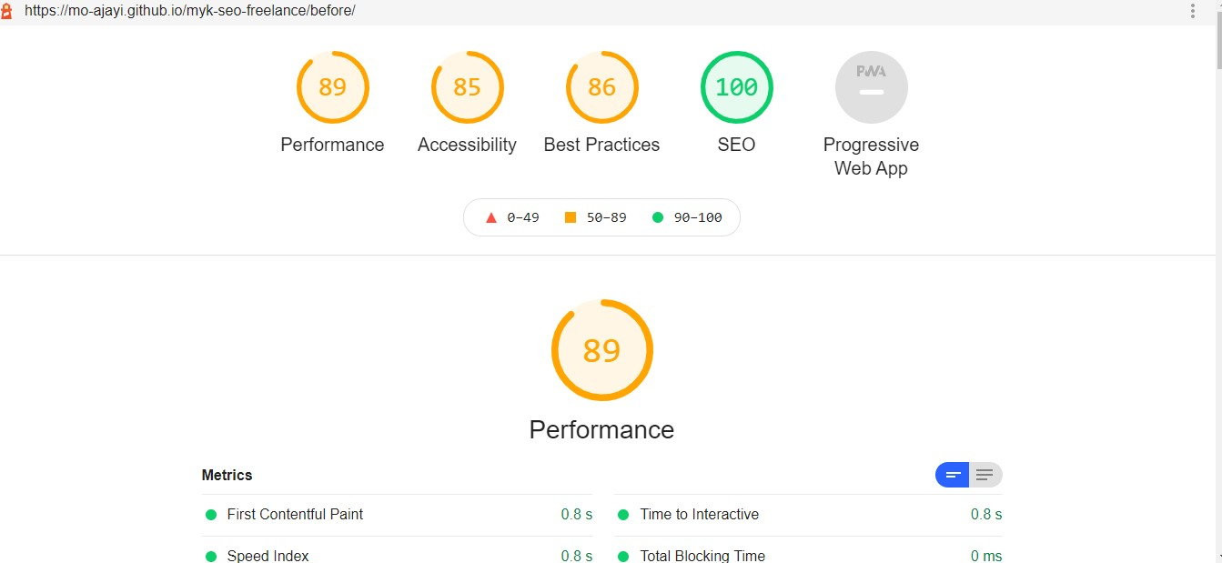

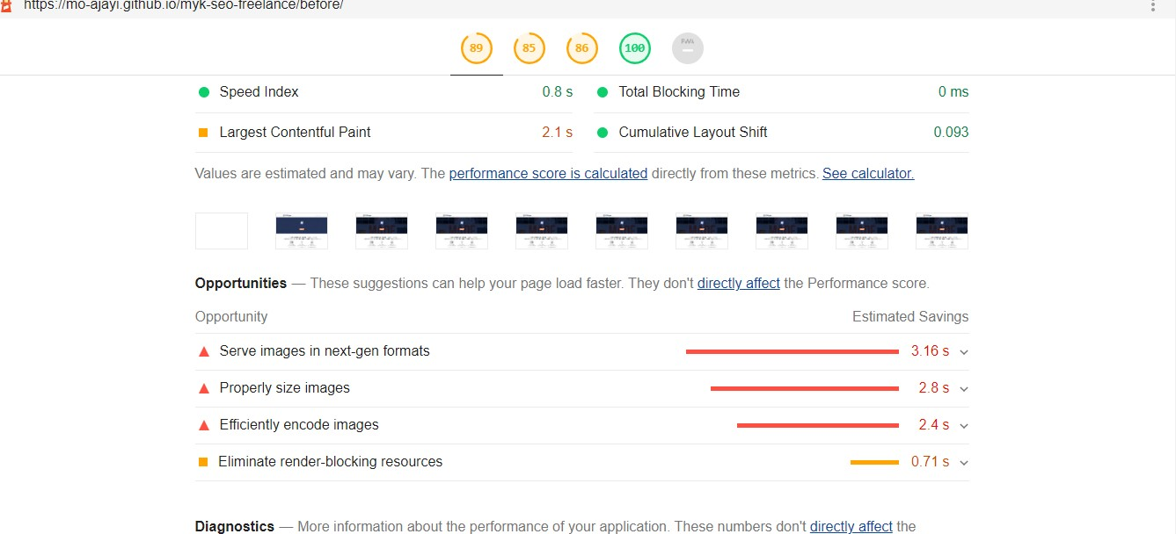

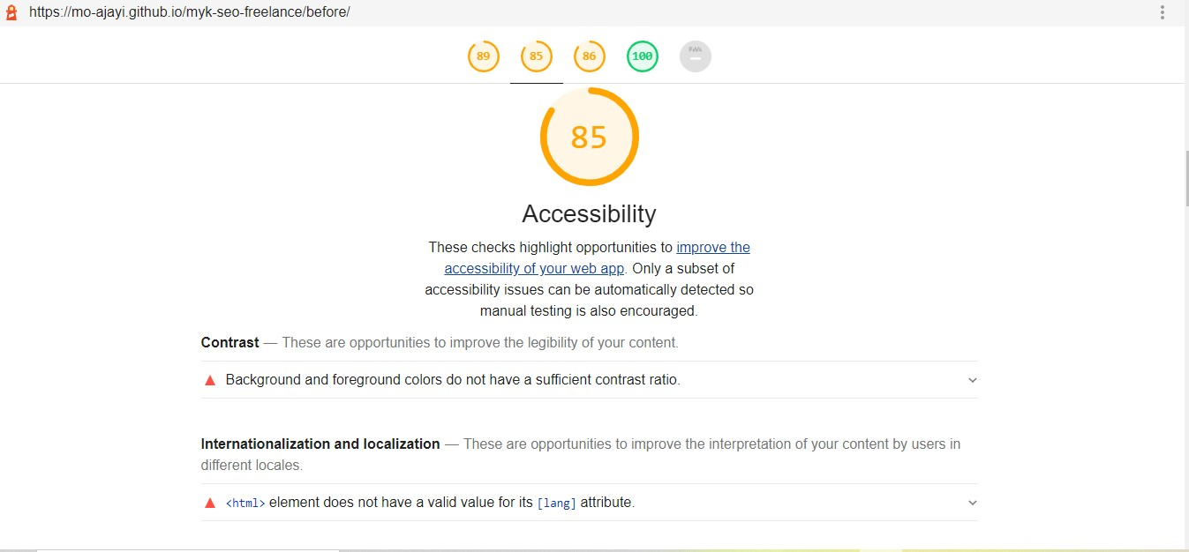

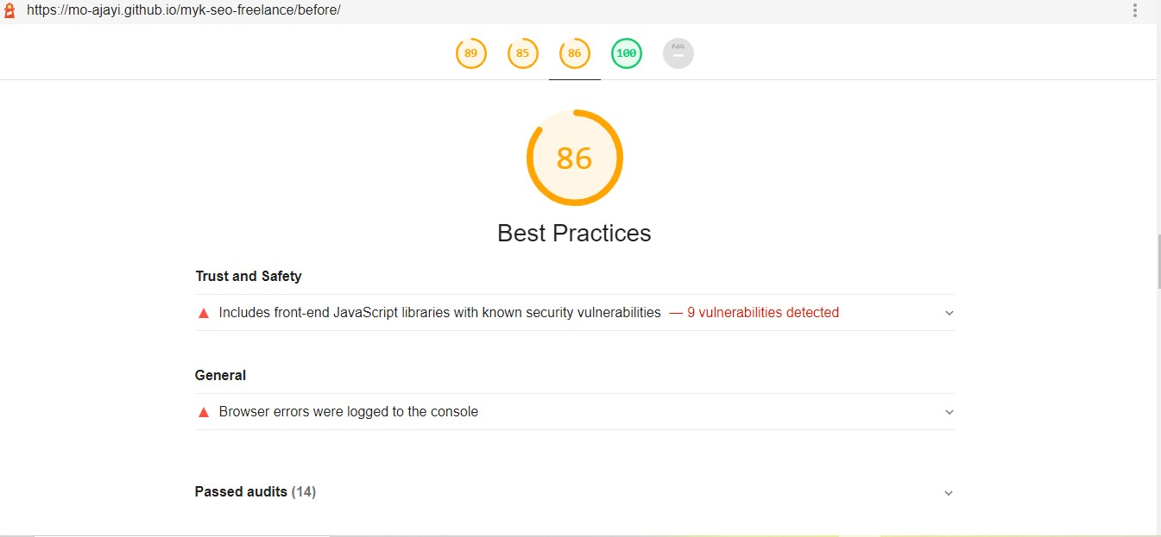

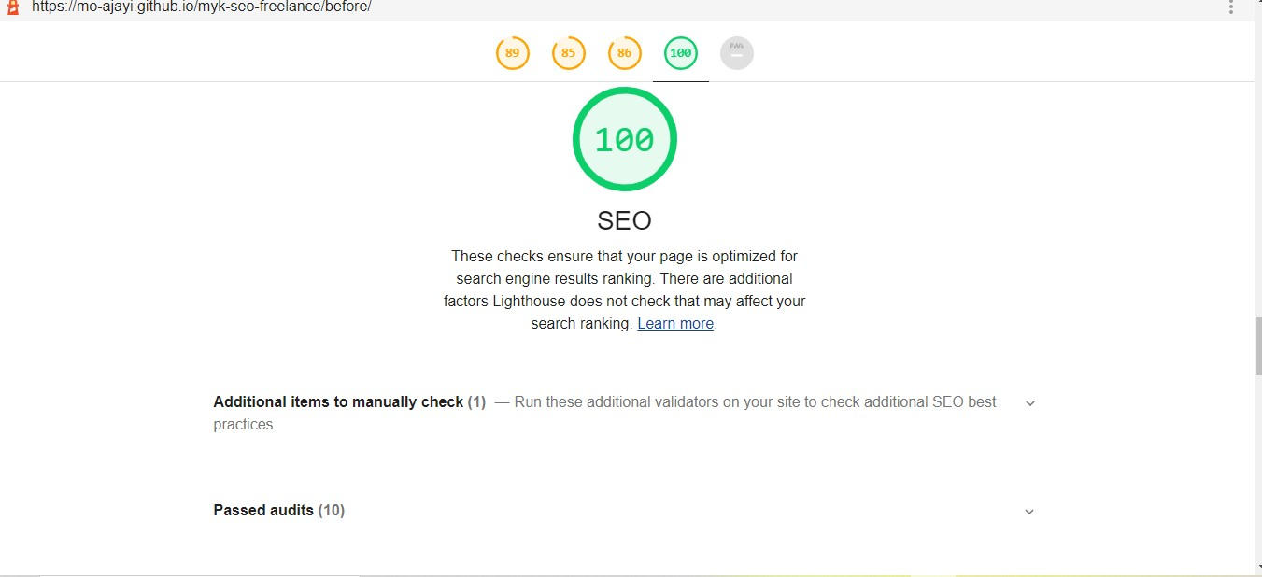

**After:**

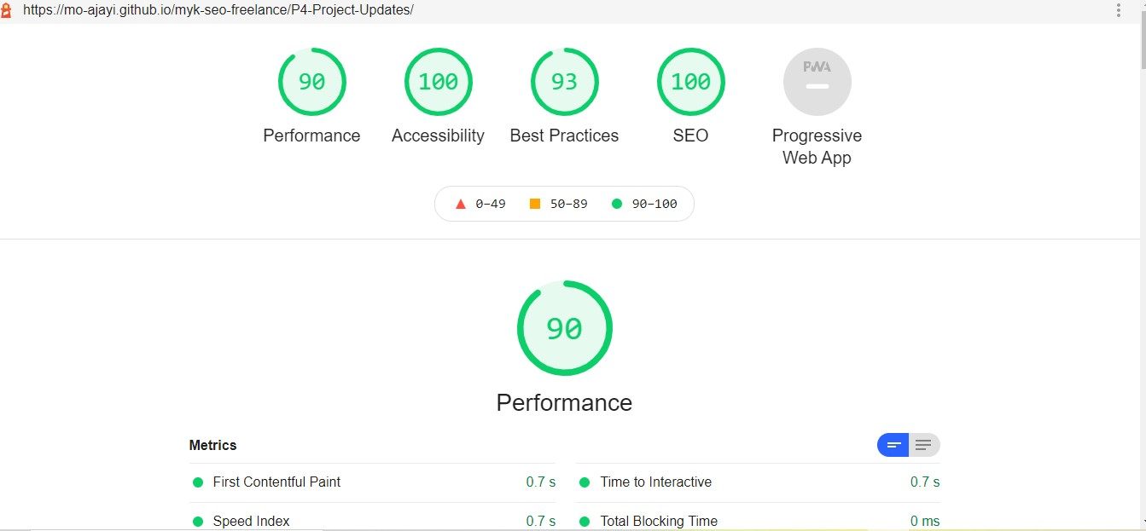

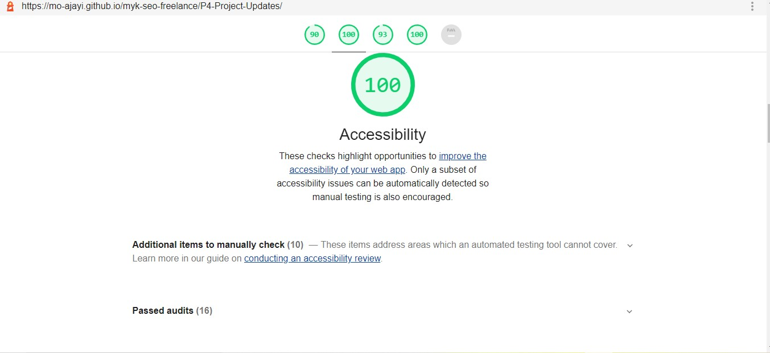

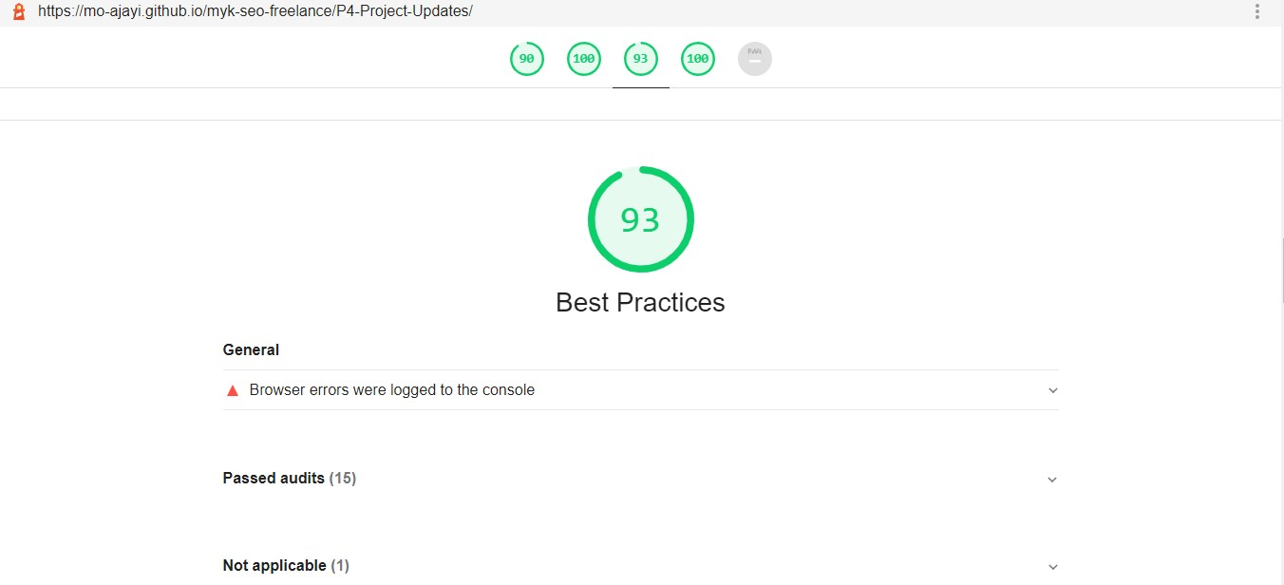

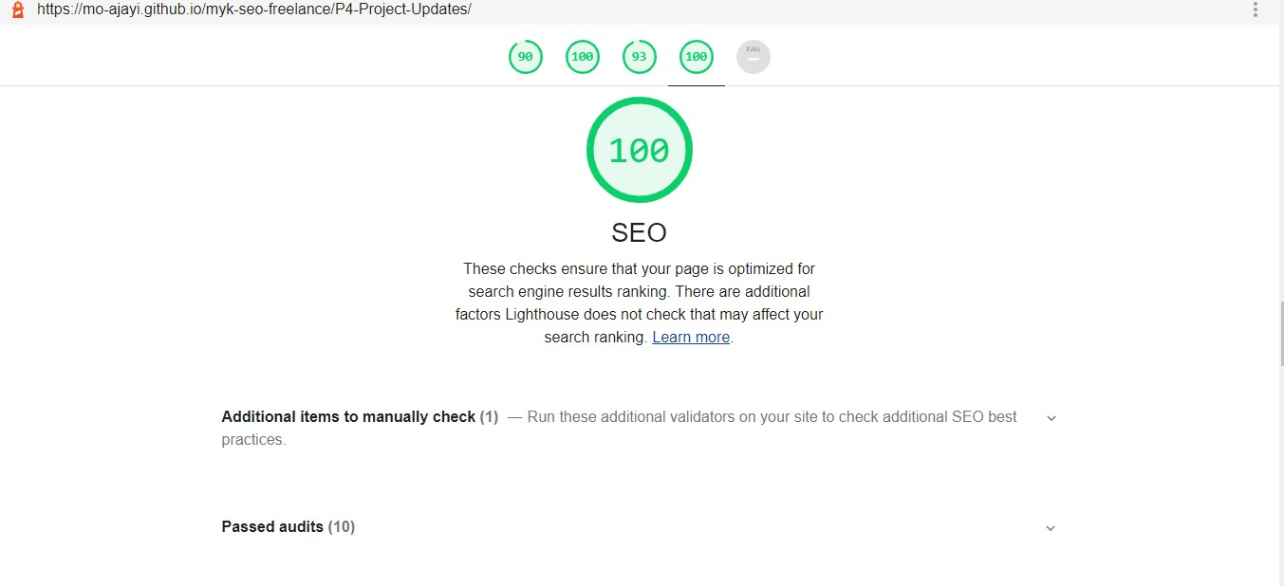

**Link:**

Website:<https://mo-ajayi.github.io/myk-seo-freelance/P4-Project-Updates/>

Github Repo:<https://github.com/Mo-ajayi/myk-seo-freelance.git>